**Factorial Knapsack Output:**

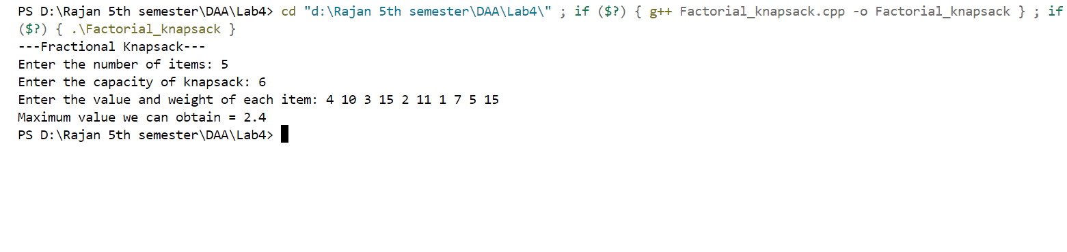

**Kruskal’s Algorithm Output:**

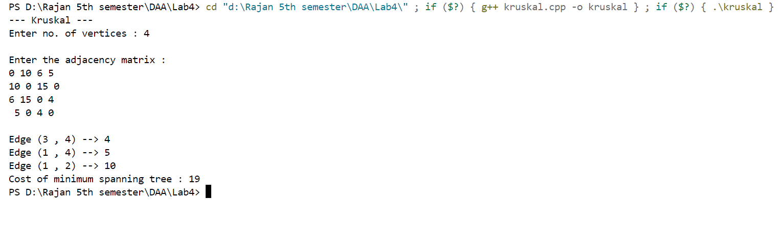

**Prims Algorithm Output:**

